**A Report on COMP 102**

**Mini Project**

**Project Title: Flight Reservation System**



**Submitted By:**

Nischal Baral

CE 2020

Roll no: 6

**Submitted To:**

Rajani Chulyadyo

Computer Department

School of Engineering

Kathmandu University

Contents

Prerequisites 3

Introduction 3

Modules 4

• Main 4

• Admin module 4

• Checking a flight status 5

• Add a flight 5

• Change flight status 6

• Cancel a flight 6

• Passenger module 7

• Reserve a seat 7

• Check your reservation 8

# Prerequisites

Please install draw.io integration on VS code to run the attached flowchart project.drawio. The explanations of the modules in this file is solely based on the flowchart project.drawio. So please read accordingly.

# Introduction

The program is a simple console program which allows user to either work as admin or as passenger in a flight system. The program allows the admin to create flights, view flight status, change flight status and cancel flights. The program allows the passenger to check flight status, reserve a seat and check their reservations.

# Modules

## Main

This is the entry point of the program. It calls a function to ask the user for the login id right at the beginning. Then after getting the login id, the program checks the id and sends the user to either admin or passenger panel as the condition of login id. The program sends the user to admin panel if the login id is between 1 to 99 and to passenger panel if it is above 99. The program exits if the entered login id is 0.

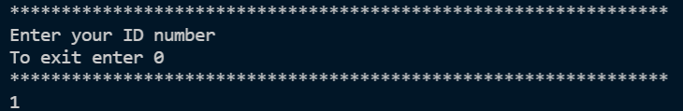

## Admin module

This panel allows the user to get the admin control. The module asks the user for input of the selection of the option after printing the available options. If the user selects the logout option then the program leads to the main function.

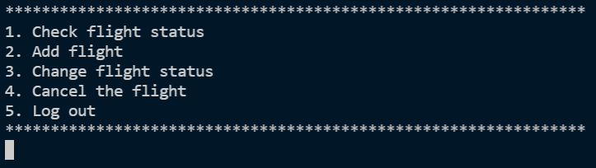

## Checking a flight status

This module can be accessed from both admin and passenger panel. This module just prints the flight status and the available seats using ASCII characters and also in color using windows.h header file. The input taken from the user is the 3 lettered code given to each flight. Then another function is called to add .txt to the entered string. As the details of the flight are stored as individual file for each flight, the specific file is opened and the data of the file are read and printed to the user.

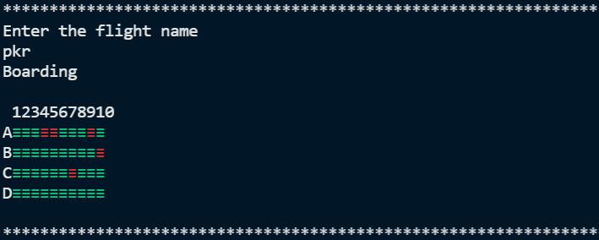

## Add a flight

This module allows the user to create new flight and provide its flight status. The user has to enter the flight name as 3 lettered code and the program creates a file and stores the status after taking input from the user and initializing all seats as vacant. The program is designed as each plane has only 40 seats in total but it can be modified later as required by changing the code.

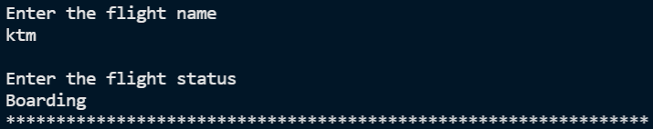

## Change flight status

This module allows the user to change the status of the flight. The user has to enter the flight code and the new status for the plane. For this function to work the flight file must preexist or else error will occur. The file is first opened to read all the data and then the file is again opened in write mode and the new data is overwritten in the file to change the condition.

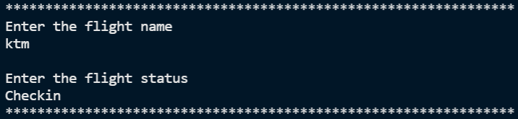

## Cancel a flight

This module allows the user to cancel a specific flight. The program asks the user for the flight name and overwrites its data as CANCLED which is checked before printing and the canceled flight’s seats are also not displayed.

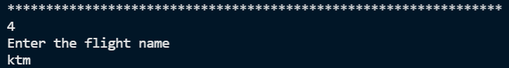

## Passenger module

This accepts the user as a passenger and give its respective rights. The module asks the user for input of the selection of the option after printing the available options. If the user selects the logout option then the program leads to the main function.

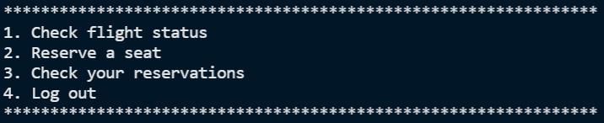

## Reserve a seat

This allows the user to reserve a seat. The flight name is asked from the user and its status and available seats are shown and the user can select the wanted seat which will be reserved and the seat reservation is stored in a separate file after asking the user for a reservation code.

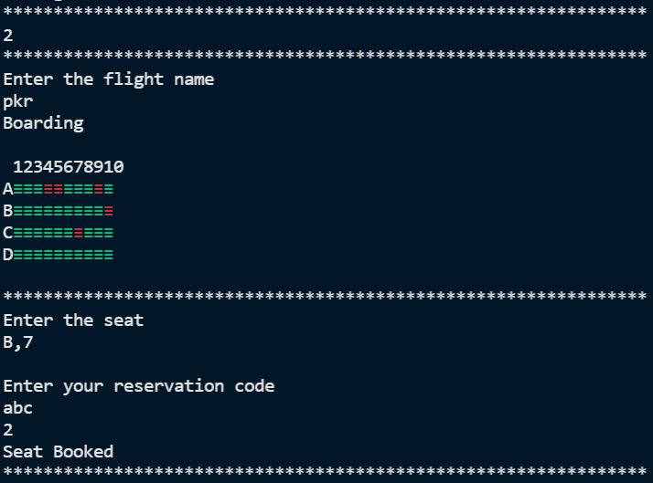

## Check your reservation

The data stored in the file named after the user entered reservation code is holding the seat value. The seat value is read and printed. The limitation here is that it cannot display the name of the flight while printing the seat no.

